DevOps Engineer Assignment

Containerized, Kubernetes-Based OCR Microservices Platform with GitOps and Monitoring
DevOps Engineer Assignment
Technologies: Python, FastAPI, KServe, Tesseract OCR, Docker, Kubernetes, Minikube, Helm, ArgoCD, Prometheus, Grafana
Repository: https://github.com/FlorinNatha/ocr-devops-assignment
Author: Nathasha Florin
Date: 24 August 2026

1. Executive Summary
This project implements a complete DevOps workflow for deploying an Optical Character Recognition (OCR) inference platform as a set of containerized microservices.
The system consists of two primary services:
- FastAPI API Gateway – receives image uploads from clients and forwards OCR inference requests to the model service.
- KServe-based OCR Model Service – processes the image using Tesseract OCR and returns the extracted text using the KServe V2 inference protocol.
The application is containerized using Docker and deployed to a local Kubernetes cluster running on Minikube. Helm charts are used to package and deploy the application components. ArgoCD provides GitOps-based continuous deployment by monitoring the Git repository and synchronizing changes to the Kubernetes cluster.
For observability, Prometheus and Grafana are deployed using the kube-prometheus-stack. Prometheus collects application and Kubernetes metrics, while Grafana provides dashboards for monitoring inference traffic, latency, errors, CPU utilization, and memory usage.
The implementation also includes automation scripts for container image building, testing, infrastructure setup, image publishing, and cleanup.
The overall solution demonstrates the following DevOps practices:
- Microservice architecture
- Containerization
- Infrastructure automation
- Kubernetes deployment
- Helm-based application packaging
- GitOps using ArgoCD
- Monitoring using Prometheus and Grafana
- Kubernetes security and RBAC
- Reproducible deployments
- Automated operational workflows

2. Assignment Objectives
The objective of this assignment was to design and implement a simple two-service OCR inference platform and deploy it using modern DevOps technologies.
The implementation addresses the following requirements:
- Run and test the provided OCR services locally.
- Containerize the FastAPI gateway and KServe OCR model.
- Build and test Docker images.
- Publish container images to Docker Hub.
- Create a Minikube Kubernetes environment.
- Deploy the services using Helm.
- Configure Kubernetes networking, service accounts, RBAC, and security contexts.
- Install and configure ArgoCD for GitOps deployment.
- Configure Prometheus and Grafana for monitoring.
- Expose and visualize OCR inference metrics.
- Automate infrastructure and application deployment using Bash scripts.
- Provide documentation that allows the complete environment to be reproduced.

3. Solution Architecture
The solution follows a microservice architecture in which the API Gateway and OCR model are deployed as independent Kubernetes workloads.

3.1 High-Level Architecture
The request flow is:
Client → FastAPI Gateway → KServe OCR Model → Tesseract OCR → Response
The deployment and operational flow is:
GitHub → ArgoCD → Helm Charts → Kubernetes
The monitoring flow is:
OCR/Gateway Metrics → Prometheus → Grafana Dashboard

Architecture Diagram

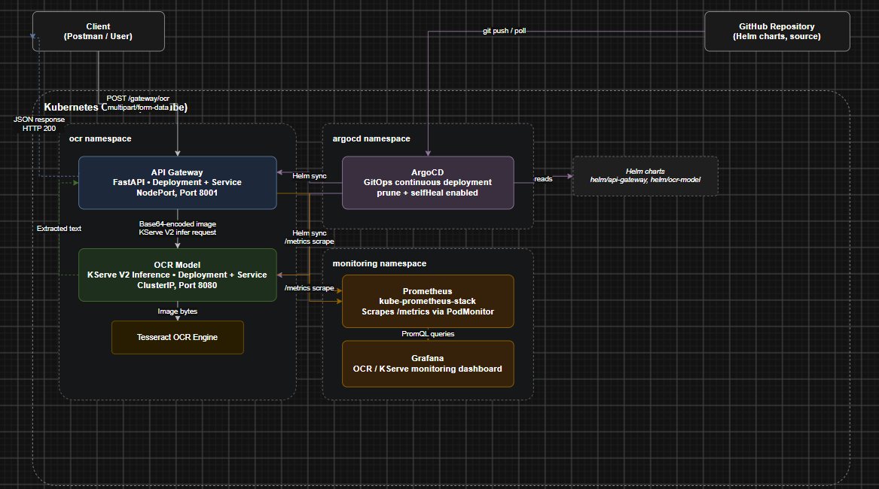

4. Technology Stack
Component | Technology
Programming Language | Python 3.12
OCR Engine | Tesseract OCR
OCR Python Library | pytesseract
Model Serving | KServe V2 inference protocol
API Gateway | FastAPI
Dependency Management | Poetry
Containerization | Docker
Container Registry | Docker Hub
Orchestration | Kubernetes
Local Kubernetes | Minikube
Package Management | Helm
GitOps | ArgoCD
Metrics | Prometheus
Visualization | Grafana
Monitoring Stack | kube-prometheus-stack
Automation | Bash
API Testing | Postman
Source Control | Git / GitHub

5. Repository Structure
The project is organized into separate application, infrastructure, deployment, monitoring, and documentation components.
ocr-devops-assignment/
│
├── ocr-model/
│ ├── model.py
│ ├── pyproject.toml
│ ├── poetry.lock
│ ├── Dockerfile
│ └── .dockerignore
│
├── api-gateway/
│ ├── api-gateway.py
│ ├── pyproject.toml
│ ├── poetry.lock
│ ├── Dockerfile
│ └── .dockerignore
│
├── helm/
│ ├── ocr-model/
│ │ ├── Chart.yaml
│ │ ├── values.yaml
│ │ └── templates/
│ │
│ └── api-gateway/
│ ├── Chart.yaml
│ ├── values.yaml
│ └── templates/
│
├── argocd/
│ ├── values.yaml
│ ├── apps.yaml
│ ├── project.yaml
│ └── applicationset.yaml
│
├── monitoring/
│ ├── values.yaml
│ ├── kserve-podmonitor.yaml
│ ├── kserve-dashboard-configmap.yaml
│ └── grafana-secret.yaml
│
├── infrastructure/
│ └── setup-infrastructure.sh
│
├── scripts/
│ ├── build-images.sh
│ ├── test-images.sh
│ ├── push-images.sh
│ └── cleanup-docker.sh
│
└── docs/
├── containerization.md
├── infrastructure-setup.md
└── task4-kubernetes-deployment.md
The structure separates application source code from infrastructure and deployment configuration, making the repository easier to maintain and reproduce.

6. Task 1 – Local Setup and Testing

6.1 Local Environment
The services were first configured and tested locally before containerization.
The development environment uses:
- Ubuntu / WSL 2
- Python 3.12
- Poetry
- Tesseract OCR
Tesseract is installed as an operating-system dependency because the OCR model uses the Tesseract executable through pytesseract.
Poetry is used to provide deterministic Python dependency management based on the project's pyproject.toml and poetry.lock files.

6.2 OCR Model Service
The OCR model service is implemented using KServe-compatible Python serving functionality.
The model accepts inference requests using the KServe V2 protocol and processes the supplied image using Tesseract OCR.
The local model service runs on:
Port: 8080
The model inference endpoint follows the KServe V2 format:
/v2/models/ocr-model/infer

6.3 FastAPI Gateway
The FastAPI gateway provides the external API consumed by clients.
Its responsibilities are:
- Accept an image upload.
- Read the uploaded image.
- Encode the image into Base64.
- Construct the KServe inference request.
- Send the request to the OCR model service.
- Return the OCR result to the client.
The gateway runs on:
Port: 8001
The primary endpoint is:
POST /gateway/ocr
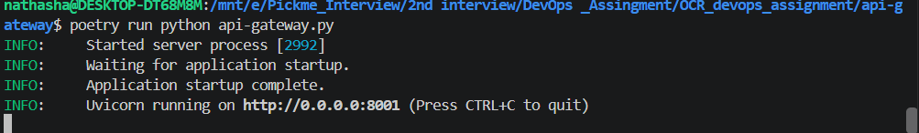

6.4 Local Testing
The system was tested using Postman.
The request configuration is:
Parameter | Value
Method | POST
URL | http://localhost:8001/gateway/ocr
Body | form-data
Field | image_file
Field Type | File
An image containing readable text is uploaded through Postman.
The gateway forwards the request to the model service, and the extracted text is returned to the client.
This validates the complete local request flow before containerization.
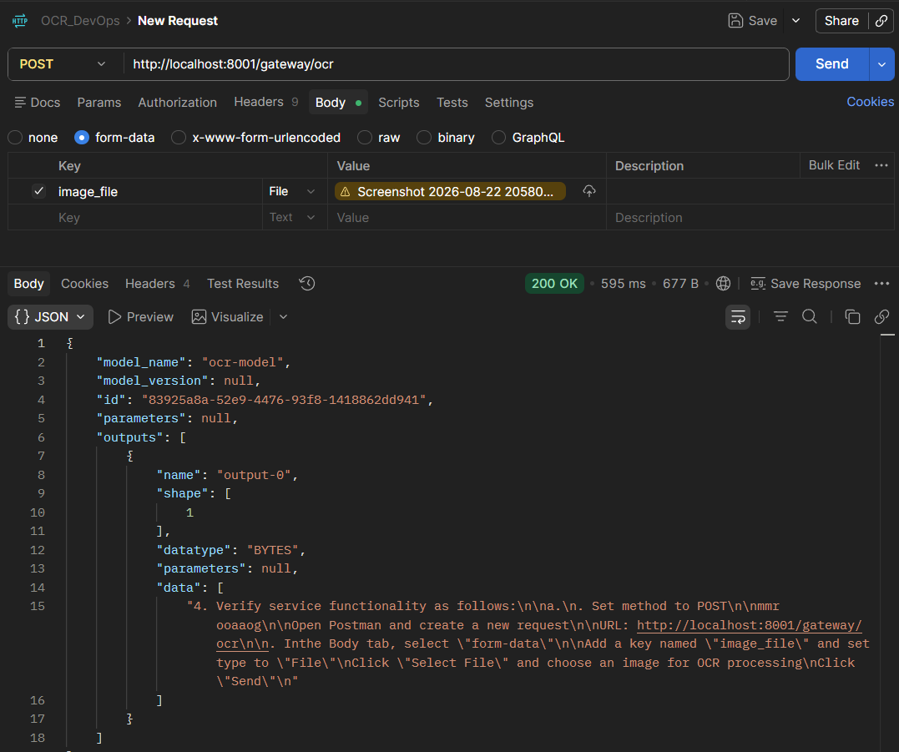

7. Task 2 – Containerization

7.1 Containerization Strategy
Both services are packaged as independent Docker images.
This provides:
- Isolation between services
- Consistent runtime environments
- Reproducible deployments
- Easy versioning
- Portability between local and Kubernetes environments
The OCR model image contains Tesseract because it is required for OCR processing.
The API Gateway image does not contain Tesseract because it only handles HTTP requests and communicates with the OCR service.

7.2 Docker Image Design

7.2.1 Base Image Selection
The services use:
python:3.12-slim-bookworm
The Slim Debian image was selected because it provides the required Python runtime while keeping the container significantly smaller than a full Python image.
Debian Bookworm also provides a stable base environment for installing Tesseract.

7.2.2 Dependency Management
Poetry is used during image construction.
The Dockerfiles first copy:
pyproject.toml
poetry.lock
and install dependencies before copying the application source.
This allows Docker to reuse the dependency installation layer when application source code changes.
7.2.3 Container Security
The containers do not run as root.
A dedicated user is created:
UID: 10001
The application is then executed using this non-root user.
This reduces the impact of a potential container compromise.
Kubernetes additionally applies security restrictions such as:
- runAsNonRoot
- Dropping Linux capabilities
- Read-only root filesystem where applicable

7.2.4 Build Optimization
The following optimization techniques are used:
- Slim base images
- .dockerignore
- Pinned Poetry version
- poetry.lock
- --no-cache-dir
- --no-root
- Removal of package manager cache
- Dependency layer caching
- Separate images for each microservice
These practices reduce image size and improve build reproducibility.

7.3 Docker Image Testing
Automation scripts were created to simplify image operations and generate versioned container images:
- ocr-model:1.0.0
- api-gateway:1.0.0

Docker Desktop Build Verification
Both microservice Dockerfiles were compiled and verified using Docker Desktop Buildx:
- OCR Model Image (ocr-model:1.0.0): Build status Completed in 3m 33s (11 steps).
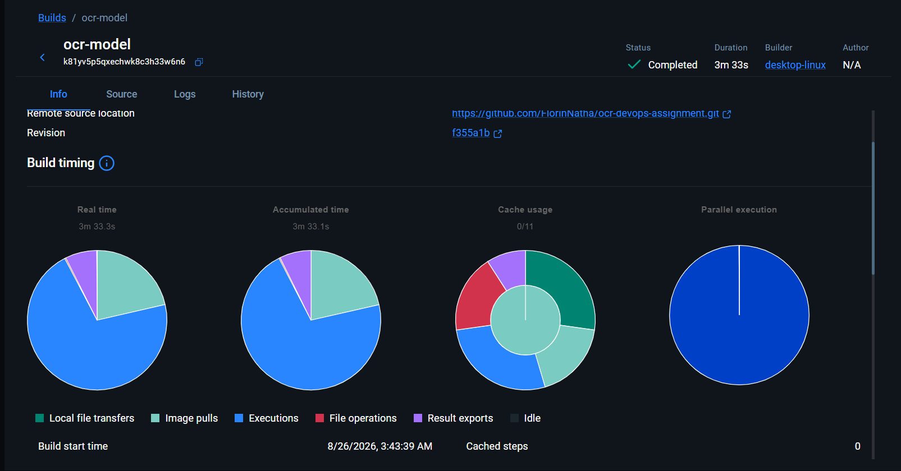
Figure 7.1: OCR Model Image Build Overview (ocr-model:1.0.0)
- API Gateway Image (api-gateway:1.0.0): Build status Completed in 21.6s (10 steps).
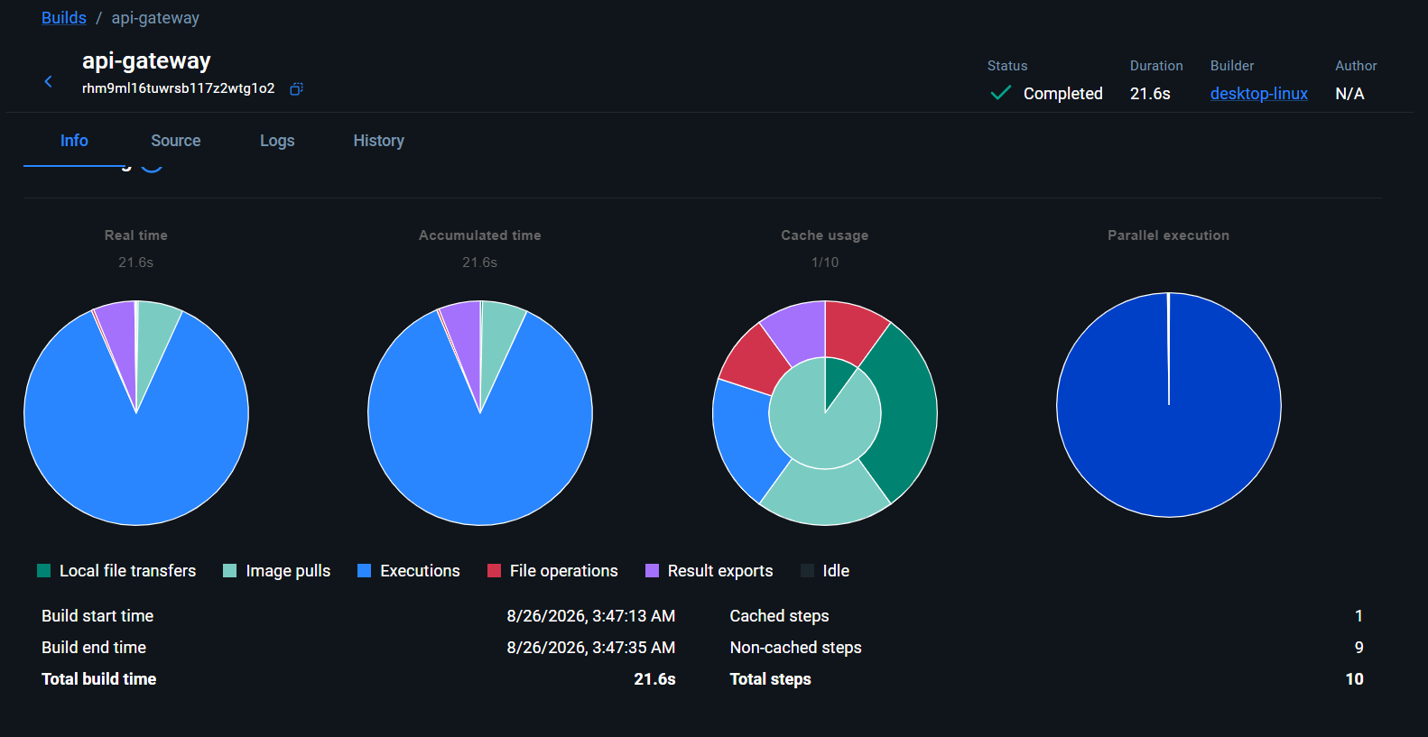
Figure 7.2: API Gateway Image Build Overview (api-gateway:1.0.0)

Isolated Container Network Testing
The testing script (scripts/test-images.sh) runs both containers inside an isolated Docker network (ocr-network) and sends a sample request to http://localhost:8001/gateway/ocr to verify inter-container communication before Kubernetes deployment.

7.4 Docker Hub
The container images are published to Docker Hub using versioned tags.
The image naming convention separates the two services:
<repository>:model-1.0.0
<repository>:gateway-1.0.0
Versioned tags ensure that Kubernetes deployments can reference a known immutable application version rather than relying on the latest tag.
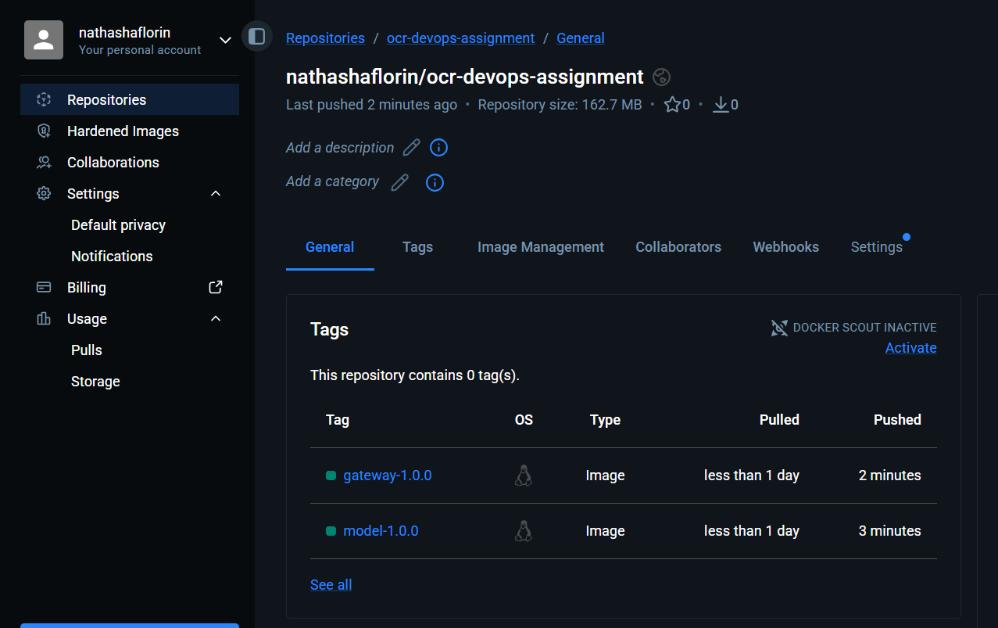

8. Task 3 – Infrastructure Setup

8.1 Minikube
The Kubernetes environment is implemented using Minikube with the Docker driver.
The development cluster was configured with:
- 4 CPUs
- 7 GB RAM
- 30 GB disk
These settings provide sufficient resources for the OCR services together with ArgoCD, Prometheus, Grafana, and Kubernetes system components.

8.2 Kubernetes Namespaces
The environment is logically separated into namespaces:
Namespace | Purpose
ocr | Application workloads
argocd | ArgoCD components
monitoring | Prometheus and Grafana
This separation improves organization and reduces accidental interaction between unrelated components.

8.3 Infrastructure Automation
A central infrastructure script was created:
infrastructure/setup-infrastructure.sh
The script automates the major infrastructure setup operations.
It performs tasks including:
- Validating required CLI tools.
- Starting Minikube.
- Enabling required Minikube addons.
- Creating Kubernetes namespaces.
- Adding Helm repositories.
- Installing ArgoCD.
- Installing Prometheus and Grafana.
- Applying monitoring resources.
- Validating the resulting cluster.
This reduces manual configuration and makes the environment easier for another developer or reviewer to reproduce.

8.4 ArgoCD Installation
ArgoCD is installed using its official Helm chart.
Resource configuration was adjusted for a local Minikube environment rather than a production-sized Kubernetes cluster.
This is important because ArgoCD and monitoring components can consume significant CPU and memory.
The configuration therefore balances functionality with the resource limitations of a local development machine.

8.5 Monitoring Stack
The monitoring environment uses:
kube-prometheus-stack
This provides:
- Prometheus
- Grafana
- Prometheus Operator
- Kubernetes monitoring
- Alerting-related components
- Grafana dashboard integration
Prometheus is responsible for collecting metrics, while Grafana is used to visualize those metrics.

9. Task 4 – Kubernetes Deployment

9.1 Helm
Separate Helm charts were created for the two application services.
helm/ocr-model
helm/api-gateway
Helm provides:
- Reusable Kubernetes templates
- Centralized configuration
- Versioned application packaging
- Consistent deployment
- Easier environment configuration

9.2 OCR Model Kubernetes Deployment
The OCR model is deployed as a Kubernetes Deployment.
The model is exposed internally through a Kubernetes ClusterIP Service.
This is intentional because the OCR model should not be directly exposed to external clients.
The request flow is:
External Client
↓
API Gateway
↓
ClusterIP Service
↓
OCR Model Pod
This creates a clear service boundary.

9.3 API Gateway Kubernetes Deployment
The FastAPI gateway is deployed separately.
The gateway is exposed using a NodePort service for local Minikube access.
The gateway provides the external entry point for OCR requests.
The model service address is injected through Kubernetes configuration rather than hardcoded directly into the deployment.
This allows the model service location to be changed without modifying application source code.

9.4 Kubernetes Resources
The Helm charts include the required Kubernetes resources.

Deployments
Manage the application pods and provide:
- Replica management
- Restart behavior
- Health probes
- Container configuration

Services
Provide stable network endpoints for the applications.

ConfigMaps
Used for non-sensitive application configuration such as the model service URL.

ServiceAccounts
Each service uses a dedicated service account instead of the default account.

Roles and RoleBindings
Provide Kubernetes RBAC permissions according to the application's requirements.

Secrets
Sensitive configuration such as administrative credentials is stored using Kubernetes Secrets.

9.5 Kubernetes Security
Security was considered at both the container and Kubernetes levels.
The workloads use security contexts including:
runAsNonRoot: true
Linux capabilities are dropped:
capabilities:
drop:
- ALL
The containers are also configured to use a read-only root filesystem where supported.
These controls reduce the privileges available to the running applications.

9.6 Health Checks
Kubernetes liveness and readiness probes are configured for the application deployments.

Readiness Probe
Determines whether the container is ready to receive traffic.

Liveness Probe
Determines whether the container is still functioning correctly.
These probes allow Kubernetes to automatically remove unhealthy pods from service traffic and restart containers when necessary.
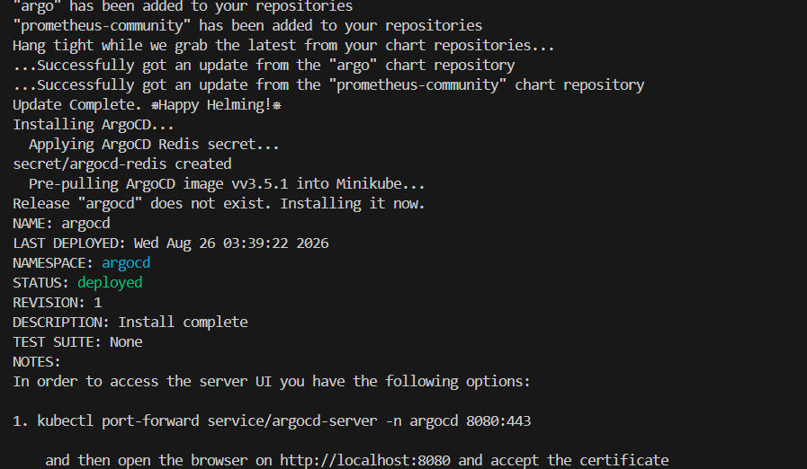

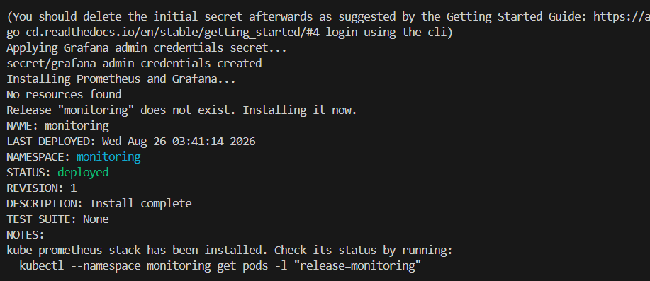
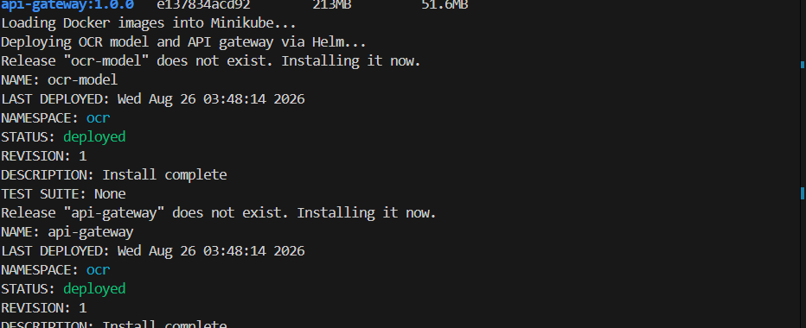

10. Task 5 – GitOps with ArgoCD

10.1 GitOps Architecture
ArgoCD is used to implement GitOps-based application deployment.
The Git repository acts as the desired-state source.
The deployment flow is:
Developer
│
│ git push
▼
GitHub Repository
│
▼
ArgoCD
│
▼
Helm Chart
│
▼
Kubernetes Cluster
This separates application deployment from manual kubectl operations.

10.2 ArgoCD Application Configuration
ArgoCD Applications are configured for:
- API Gateway
- OCR Model
Each Application points to its corresponding Helm chart directory.
For example:
helm/api-gateway
helm/ocr-model
The target Kubernetes namespace is:
ocr
The repository tracks the main branch.

10.3 Automated Synchronization
The ArgoCD Applications use automated synchronization.
Important settings include:

Automated Pruning
prune: true
Resources removed from Git can also be removed from the Kubernetes cluster.

Self-Healing
selfHeal: true
If a resource is manually modified in Kubernetes, ArgoCD can restore the desired state defined in Git.

Retry
Failed synchronization attempts are retried using ArgoCD's retry configuration.
This improves deployment reliability.

10.4 AppProject and ApplicationSet
The repository also includes ArgoCD configuration for:
- AppProject
- Application
- ApplicationSet
The AppProject provides a logical boundary for the applications.
The Applications define the individual deployments.
The ApplicationSet provides a scalable mechanism for managing multiple applications from a common configuration pattern.
Although the assignment does not require a complete production GitOps repository structure, these resources demonstrate how the deployment could be extended beyond the local environment.

11. Task 6 – Monitoring
Monitoring was implemented using Prometheus and Grafana.
The monitoring architecture is:
Application Pods
│
│ /metrics
▼
Prometheus
│
│ PromQL
▼
Grafana
│
▼
Monitoring Dashboard

11.1 Prometheus PodMonitor
A Prometheus PodMonitor is configured to identify the OCR-related application pods and scrape their metrics endpoints.
The OCR model exposes metrics through:
/metrics
The monitoring configuration also supports the FastAPI gateway metrics exposed through its Prometheus instrumentation.
The PodMonitor allows Prometheus Operator to discover the application metrics automatically.

11.2 FastAPI Metrics
The FastAPI gateway uses Prometheus instrumentation to expose HTTP request metrics.
These metrics provide visibility into:
- Request volume
- Request rate
- HTTP response status
- Request duration
This allows gateway performance to be monitored independently from the OCR model.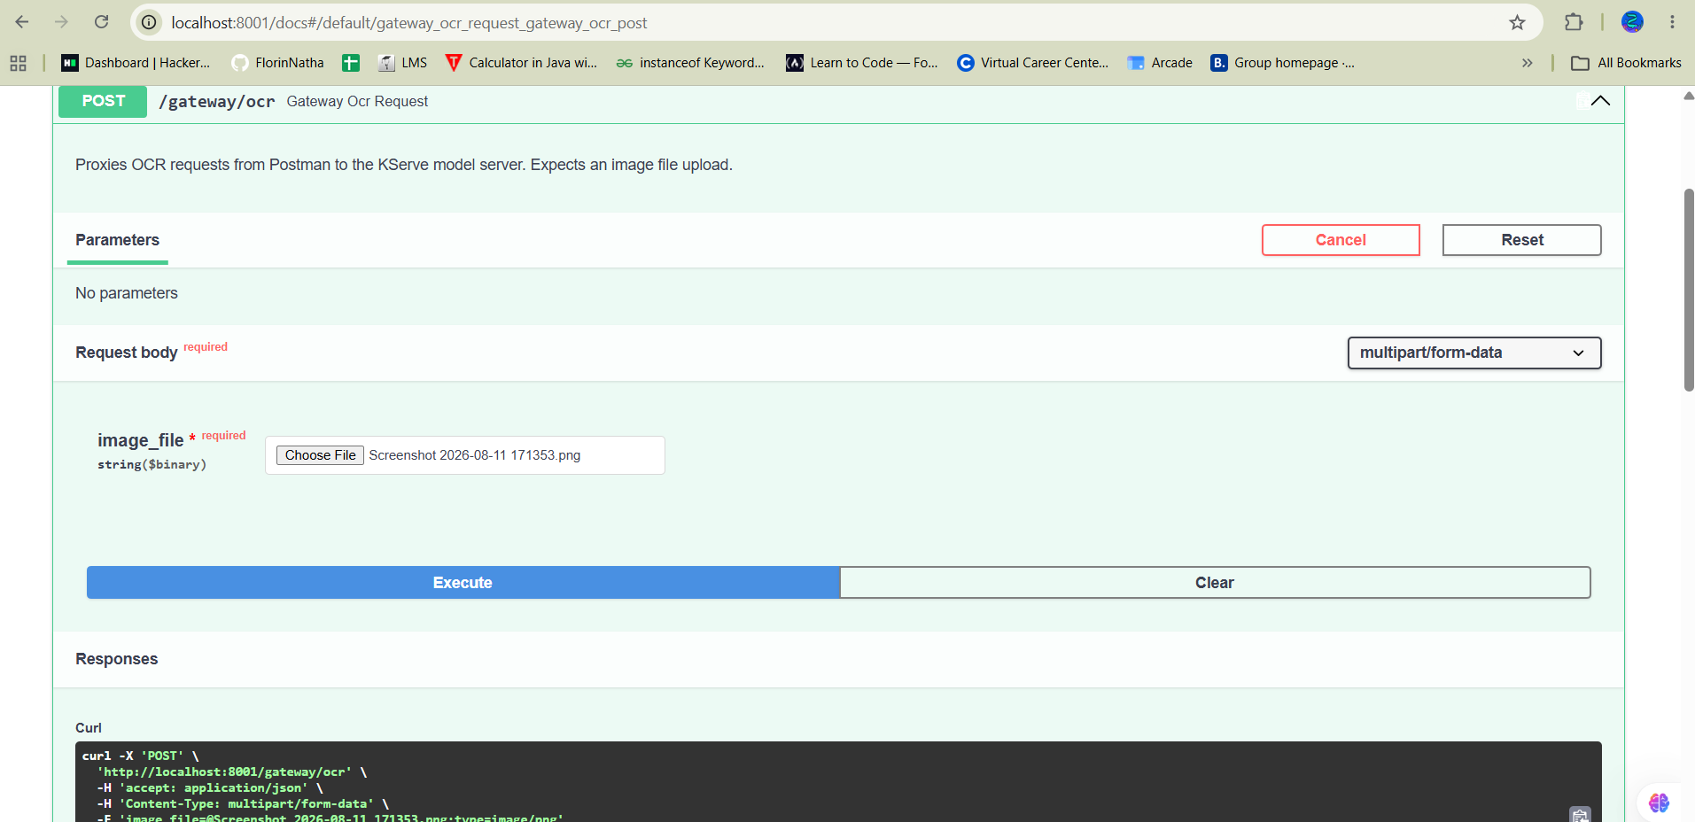

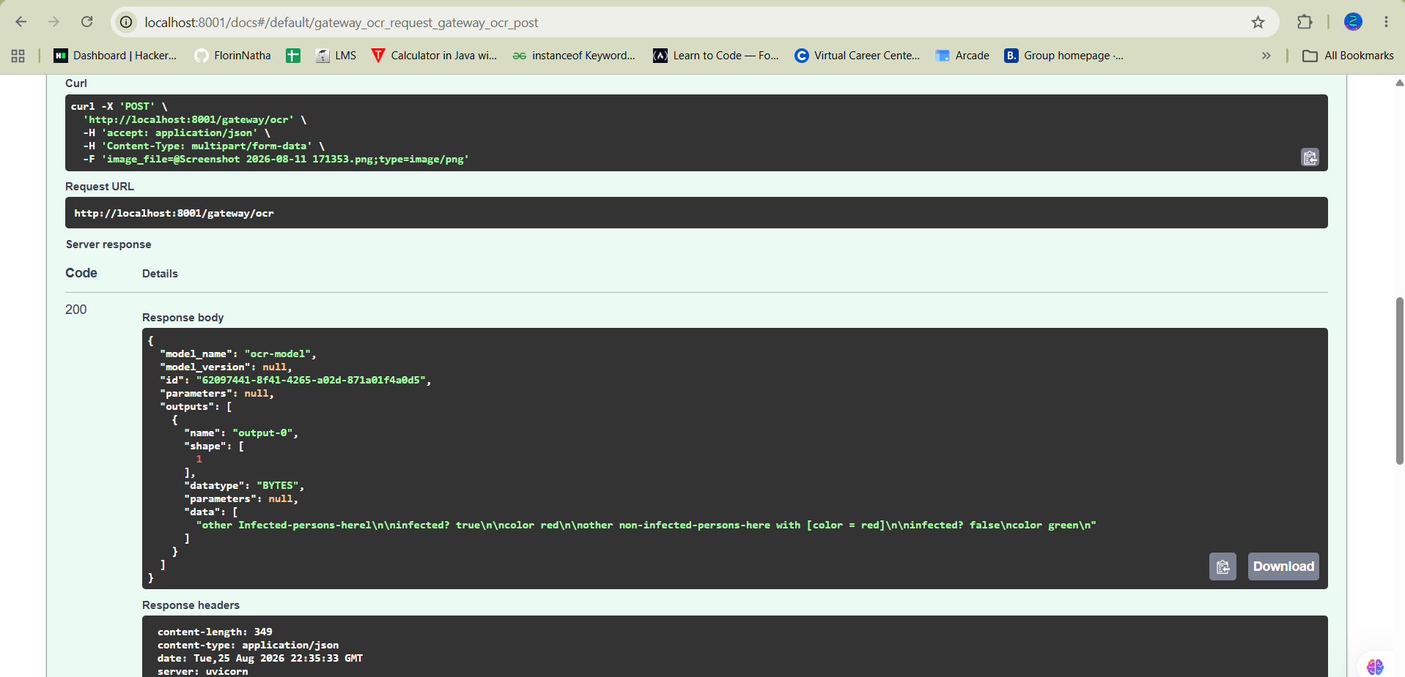

11.3 Grafana Dashboard
A custom Grafana dashboard was created specifically for the OCR application.
The dashboard is automatically provisioned through the Grafana sidecar configuration.
The dashboard focuses on the most important operational metrics.

11.4 Monitoring Metrics
The dashboard includes the following categories.

11.4.1 Inference Requests
Measures the number of OCR inference requests processed by the application.
This provides an overview of system usage.
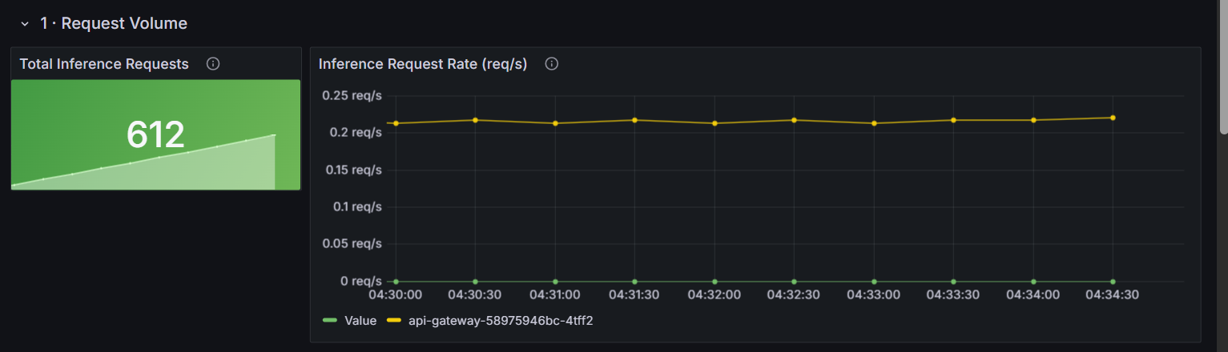

11.4.2 Request Rate
Measures the rate at which requests are received.
This can be used to identify traffic increases or unusual request patterns.

11.4.3 Inference Latency
Latency is represented using histogram-based metrics and percentile calculations.
The dashboard can display latency such as:
- P50
- P90
- P95
- P99
This helps identify performance degradation that may not be visible from average latency alone.
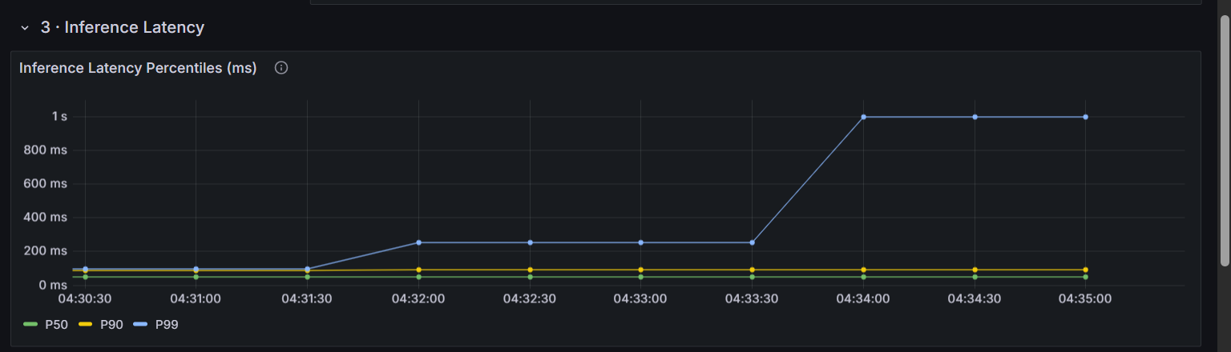
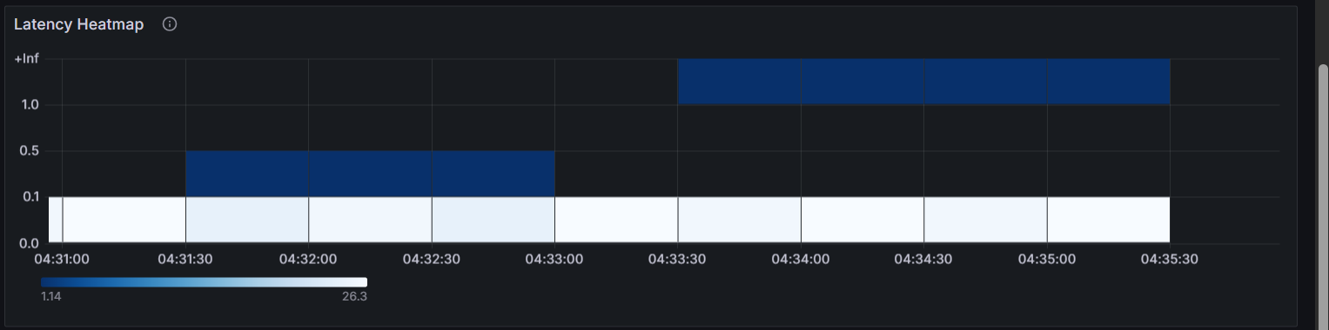

11.4.4 Error Rate
The dashboard tracks unsuccessful requests based on HTTP/model response status.
This provides an operational view of application reliability.
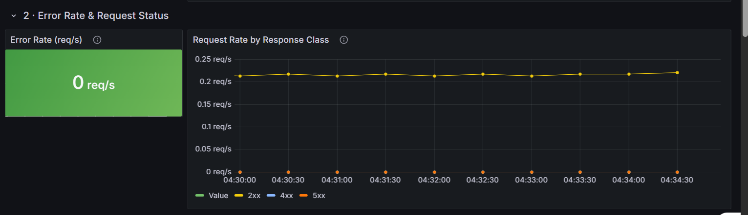

11.4.5 CPU Utilization
CPU consumption is monitored per OCR-related pod.
This helps identify workloads that may require additional CPU resources.

11.4.6 Memory Utilization
Memory working-set usage is monitored for the application pods.
This can help identify memory pressure and potential resource leaks.

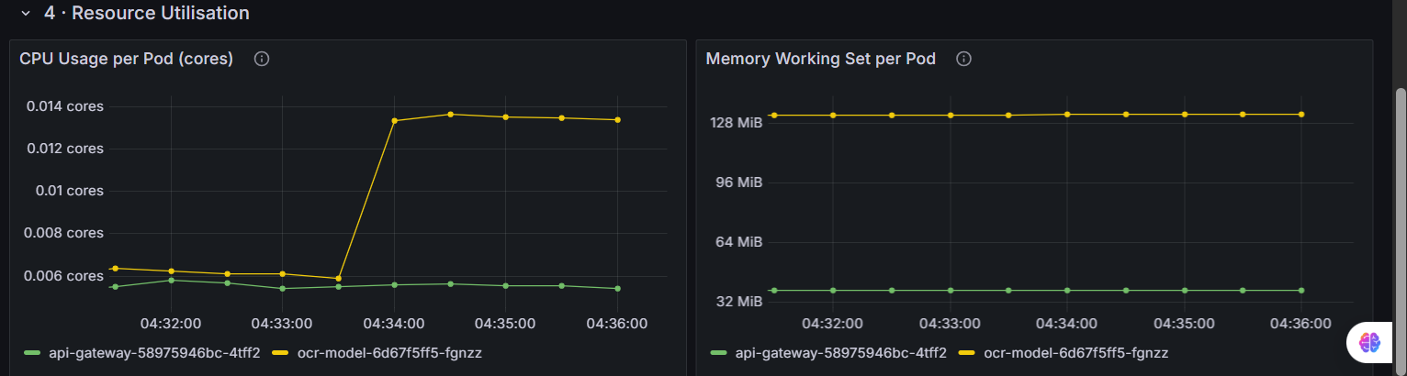

11.5 PromQL
The dashboard uses Prometheus Query Language to calculate operational metrics.
Representative queries include:

Request Rate
rate(http_requests_total[5m])

Error Rate
rate(http_requests_total{status!~"2.."}[5m])

CPU Usage
rate(container_cpu_usage_seconds_total[5m])

Memory Usage
container_memory_working_set_bytes
Histogram-based queries are used to calculate request latency percentiles.
The dashboard also uses fallback expressions where appropriate so that it can accommodate different metric naming formats.

12. Security and Secret Management
Sensitive credentials are not intended to be committed directly to Git.
The project uses Kubernetes Secret resources for sensitive configuration such as:
- ArgoCD Redis credentials
- Grafana administrator credentials
These secret manifests are excluded from version control.
Template examples can be created locally by the reviewer before running the infrastructure setup.
This prevents credentials from being accidentally published to the repository.

13. Configuration Management
Configuration is separated from application source code where appropriate.
For example, the gateway's KServe URL is provided through an environment variable:
KSERVE_URL
This allows the same application image to be used in different environments.
For local development, the model may be accessed through localhost.
Inside Kubernetes, the gateway communicates with the OCR model using its Kubernetes Service.
This follows the principle of separating configuration from application code.

14. Automation Scripts
Several Bash scripts are included in the repository.

build-images.sh
Builds Docker images for both services.

test-images.sh
Runs the containerized services and verifies connectivity.

push-images.sh
Tags and pushes images to Docker Hub.

cleanup-docker.sh
Removes locally created Docker resources.

setup-infrastructure.sh
Automates the Minikube, Helm, ArgoCD, Prometheus, and Grafana infrastructure setup.
These scripts reduce repetitive manual operations and improve reproducibility.

15. Deployment Workflow
The complete deployment workflow can be summarized as follows.

Step 1 – Develop
The OCR model and FastAPI gateway are developed and tested locally.

Step 2 – Build
Docker images are built from the individual service Dockerfiles.

Step 3 – Test
The images are tested locally using an isolated Docker network.

Step 4 – Publish
Versioned images are pushed to Docker Hub.

Step 5 – Infrastructure
Minikube is started and the supporting infrastructure is installed.

Step 6 – Helm
Helm charts define the Kubernetes deployment configuration.

Step 7 – GitOps
ArgoCD reads the Helm charts from GitHub and synchronizes the applications.

Step 8 – Monitoring
Prometheus discovers application metrics and Grafana visualizes them.

16. End-to-End Request Flow
A complete OCR request follows this sequence:
1. User selects an image
↓
2. Postman sends multipart/form-data request
↓
3. FastAPI Gateway receives image
↓
4. Gateway encodes image as Base64
↓
5. Gateway creates KServe V2 inference request
↓
6. Request is sent to OCR Model Service
↓
7. KServe model processes the request
↓
8. Tesseract performs OCR
↓
9. Extracted text is returned to model service
↓
10. Gateway returns result to client
This demonstrates the complete communication path between the external API and the inference backend.

17. Validation Strategy
The implementation was validated at multiple levels.

Local Application Validation
The services were executed independently and tested through Postman.

Container Validation
The Docker images were executed together and tested through the gateway.

Kubernetes Validation
The following Kubernetes resources were checked:
- Nodes
- Pods
- Services
- Deployments
- Namespaces

Infrastructure Validation
The following components were verified:
- Minikube
- ArgoCD
- Prometheus
- Grafana
- Metrics Server

GitOps Validation
ArgoCD Application status was checked to confirm synchronization with Git.

Monitoring Validation
Prometheus targets and Grafana dashboards were checked to verify metrics collection and visualization.

18. Troubleshooting
Several operational issues were considered during implementation.

ArgoCD Deployment Timeout
Large container images and limited local network speed can cause ArgoCD components to remain in ContainerCreating.
The solution includes increasing deployment timeouts and pre-pulling large images where appropriate.

Helm Pending Installation
If a Helm installation becomes stuck in a pending-install state, the Helm release history can be inspected and the release can be removed before attempting installation again.

Grafana Startup Issues
Grafana startup performance can be affected by unnecessary plugins and limited Minikube resources.
The monitoring configuration is therefore tuned for the local environment.

Kubernetes Metrics Availability
The Kubernetes Metrics Server must be ready before commands such as:
kubectl top nodes
kubectl top pods
can return resource utilization information.

19. Design Decisions
Several design decisions were made to keep the solution simple while maintaining good DevOps practices.

Separate Microservices
The gateway and OCR model are independently deployable.

Internal Model Service
The OCR model uses a ClusterIP service because external users should communicate through the gateway.

NodePort Gateway
NodePort provides a straightforward way to expose the gateway from Minikube.

Helm
Helm provides reusable deployment templates and centralized configuration.

ArgoCD
ArgoCD ensures Kubernetes state can be controlled through Git rather than relying entirely on manual cluster changes.

Prometheus and Grafana
Prometheus provides metric collection and Grafana provides visualization and operational dashboards.

Non-Root Containers
Running applications as non-root users reduces container security risks.

Versioned Images
Versioned Docker tags make deployments reproducible.

20. DevOps Best Practices Demonstrated
The project incorporates several DevOps principles.

Infrastructure as Code
Infrastructure configuration is stored as code using Kubernetes YAML and Helm values.

Configuration as Code
Application deployment configuration is version controlled.

GitOps
Git acts as the source of truth for application deployment configuration.

Automation
Repeated infrastructure and Docker operations are automated using Bash scripts.

Containerization
Each service has an independent container image.

Observability
Application and infrastructure metrics are collected and visualized.

Security
Containers run with restricted privileges and Kubernetes RBAC is configured.

Reproducibility
Pinned dependencies, versioned images, Helm charts, and infrastructure scripts make the environment reproducible.

21. Assignment Requirement Mapping
Assignment Requirement | Implementation
Local setup | Python 3.12, Poetry, Tesseract
Local testing | Postman
KServe model | KServe V2 OCR service
FastAPI gateway | FastAPI application
Dockerfiles | Separate Dockerfiles for both services
Docker build automation | build-images.sh
Docker testing | test-images.sh
Docker registry | Docker Hub
Infrastructure | Minikube
Kubernetes | Deployments and Services
Package management | Helm
Configuration | ConfigMaps and Values
Secrets | Kubernetes Secrets
RBAC | ServiceAccounts, Roles, RoleBindings
Security | Non-root containers and restricted capabilities
GitOps | ArgoCD
ArgoCD Application | Configured
ArgoCD AppProject | Configured
ApplicationSet | Configured
Monitoring | Prometheus
Visualization | Grafana
Model metrics | /metrics endpoint
Pod discovery | PodMonitor
Dashboard | Custom Grafana dashboard
Automation | Bash scripts
Documentation | README and docs/

22. Project Outcome
The final implementation provides a complete local DevOps environment for an OCR inference application.
The solution successfully combines:
FastAPI
+
KServe
+
Tesseract
+
Docker
+
Kubernetes
+
Helm
+
ArgoCD
+
Prometheus
+
Grafana
The architecture provides a clear separation between the client-facing API layer, OCR inference layer, deployment layer, and monitoring layer.
The use of GitOps means that application deployment configuration is maintained in Git and synchronized to Kubernetes by ArgoCD.
The monitoring stack provides visibility into application traffic, performance, errors, and resource consumption.

23. Conclusion
This assignment demonstrates the implementation of a complete DevOps workflow for a containerized machine-learning inference application.
The OCR application was separated into two independent services, containerized using Docker, and deployed to Kubernetes using Helm. Minikube provides the local Kubernetes environment, while ArgoCD introduces GitOps-based deployment management.
Prometheus and Grafana provide observability into application and infrastructure behavior, including request volume, latency, errors, CPU usage, and memory usage.
Security was considered through non-root containers, restricted Linux capabilities, Kubernetes service accounts, RBAC, and secret management.
Automation scripts reduce the amount of manual configuration required to build, test, deploy, and monitor the system.
Overall, the implementation demonstrates how a small machine-learning inference application can be transformed into a structured, reproducible, observable, and GitOps-managed Kubernetes workload.

24. Appendix – Key Commands
For quick reference, the most important operational commands are:

Start Minikube
minikube start --driver=docker --cpus=4 --memory=7168 --disk-size=30g

Check Cluster
minikube status
kubectl get nodes
kubectl get pods -A

Deploy Helm Charts
helm upgrade --install ocr-model ./helm/ocr-model \
--namespace ocr --create-namespace

helm upgrade --install api-gateway ./helm/api-gateway \
--namespace ocr

Check Application
kubectl get all -n ocr

Apply ArgoCD Resources
kubectl apply -f argocd/project.yaml
kubectl apply -f argocd/apps.yaml

Check ArgoCD
kubectl get applications -n argocd

Access Gateway
kubectl port-forward svc/api-gateway -n ocr 8001:8001

Access Grafana
kubectl port-forward service/monitoring-grafana -n monitoring 3000:80

Access Prometheus
kubectl port-forward service/monitoring-kube-prometheus-prometheus \
-n monitoring 9090:9090

